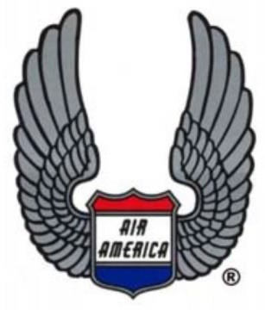
2024 Bulldog Roundup:
Air America as Remembered by the 2nd Generation
By Wes Hutchison

From October 31st to November 3rd , Terry and Kathy Bruner hosted the second Air America (AAM) “Bulldog Roundup” at their Rocking B Ranch in Lago Vista, Texas, just west of Austin. (Terry named the event since the Bulldog was our mascot at Air America School in Udorn and “Roundup” is a Texas cowboy thing.) On the heels of the 1st Bulldog Roundup held in November 2022, this event provided another group from Air America’s 2nd Generation the opportunity to come to the ranch—and not just to hang out with old friends and a bunch of longhorns—but more specifically, to provide a venue for participants to record their memories, stories, and perspectives from their time living in Thailand and Laos during the 1960s and 1970s as dependent children of Air America employees as well as other government associates working with Air America including the CIA customer. These interviews are conducted and archived by Texas Tech University—The Vietnam Center & Sam Johnson Vietnam Archive. Kelly Crager, PhD, is the head of the Oral History Project and travels to venues around the country to conduct his interviews in person or over the phone.

Once again, Terry and Kathy, along with Tammy (Rogers) Oliver, worked extremely hard to provide a welcome environment with plenty of food, drinks, and activities, as well as arranging accommodations at a nearby B&B. The Bruner’s trusty ranch hand, Andy Ripper, who is more like their adopted son, was there to man the smoker and cook some of the best fajitas in Texas—and of course, add his joviality and wise cracks to the mix. The Rocking B crew and Tammy did an outstanding job in keeping everyone busy and entertained. We highly commend the Bruners and Tammy for their time and dedication over the years to help keep our Air America organization thriving for both the 1st and 2nd Generations.

The 2nd Generation “kids” (and most of us are well into our golden years) are lightheartedly also referred to as the “brats,” as we are the children of the 1st Generation. Speaking for all of the 2nd Generation, we have great reverence and admiration for our fathers (and mothers) who worked in various critical roles at Air America, from pilots and kickers to those working the demanding and critical ground operations including logistics, aircraft maintenance, transportation, interagency communications, and dependent services, to name just a few. These employees’ heroic dedication to Air America’s covert mission supporting the war effort throughout Southeast Asia was a significant part of the Vietnam War. Their sacrifice and courage have inspired us and they will always be in our hearts. As the 1st Generation’s numbers wain with the passing years, it is our duty as their descendants to keep their memories and stories alive and permanently recorded in the military history of our country. Air America employees were generally very tight-lipped about their secret work during the war, and many remained so even after the mission was declassified. Many never had the opportunity to have their stories preserved for history. Some 2nd Generation kids recall some of the stories their fathers spoke about, and we encourage them to share what they remember with Texas Tech’s Oral History Project. We are extremely lucky to have Kelly Crager gathering and recording Air America’s multi-generational stories as a part of a highly rated academic institution interested in our history.

Event Overview and Participants
This year there were 15 Roundup participants including our hosts, Terry and Kathy Bruner, and Andy Ripper. The ranch guests for all four days included: Vicki (Kendall) Alford, Mike Cash, Lesa Densley, Wes Hutchison, Tammy (Rogers) Oliver, Dan and Tiffany (Johnson) Parker, Kim (Murray) Ray, Phil Ritter, Marlene Spencer, and Jill (Theriault) Zadrozna. Ted Bruner joined us for one evening but did not stay overnight.

Day 1 – Thursday
Tammy (Rogers) Oliver was instrumental in getting everyone picked up at the airport because she has such a wonderful and helpful attitude (not to mention she rented a minivan for the cause). Most of us arrived at the airport on Thursday within a couple hours of each other, so she only had to make two trips. Tammy also was in charge of ensuring everyone had accommodations at the B&B and she helped in planning our itinerary of activities. Thank you, Tammy!

By evening, everyone was settled into their rooms and we were soon talking about our Thailand and Laos memories, as well as our current lives. We talked about our many adventures overseas—good, bad, innocent, risqué, or otherwise—and our comradery continued for all four days. Everyone was relaxed and at ease. We were among friends with a shared history.

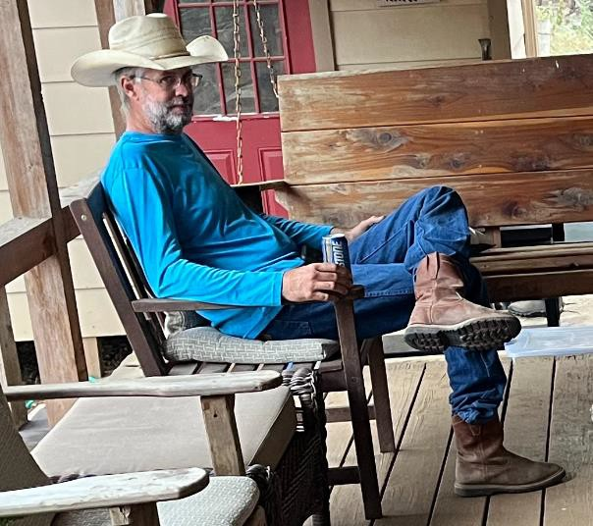
Day 2 - Friday
Mike Cash met his match with Andy Ripper, and we all were very amused listening to them poking fun and throwing barbs at each other throughout the reunion. Their verbal arm wrestling was non-stop and hilarious. Ripper is key to the Roundup. Ripper yells at the cows, tells funny stories, argues with Mike Cash continuously, cooks all the food, helps Kathy maintain sanity with all the commotion, and yells at the cows some more. Ripper all by himself is a great entertainer (someone call an agent in Hollywood!) and we all love to hang out with him.

Kelly Crager arrived Friday morning to conduct the oral history interviews. Kelly is highly committed to documenting all the recollections possible from people who were directly or indirectly involved in America’s wars. Following a similar format as the first Roundup interviews in 2022, we all gathered on the shaded back porch overlooking the cow pens. Kelly started with a round robin format, but it often resulted with another person chiming in when one story would trigger an associated memory, and his high-tech apparatus was able to identify each speaker The session was a cascade of our experiences and lives at home, school, places on and off the Air Force base, and various trips we took in Thailand and Laos. We also talked about how our fathers’ work affected us in our daily lives.

We may only have seen elements of the war from a safe distance, but we were still close to the action at times while living in Udorn, Vientiane, and Saigon. We experienced unfamiliar and exotic aspects of living in an Asian culture, with places, customs, and events that state-side American children never could have imagined. Reminiscing on the porch with Kelly brought back lost memories, feelings, and some anxieties. Our appreciation of our exceptional lives from so long ago permeated and surrounded everyone as we mentally rolled back the years and returned to our younger and innocent selves. Our unique life during the War, as seen through the eyes of a child, has been deeply imbedded in our memories even though at the time, we barely comprehended the purpose of our presence overseas.

A few AAM Memories
Our recollections with Kelly were too numerous to be recounted here for this article but here are a few of the stories:

- Wes Hutchison - School life was sometimes a little different than what was normal in the States. The ancillary effects from the Air Force base next to us that was actively fighting a war were obvious. The deafening noise of the F- 4 fighter jets taking off would completely shut down our teacher’s lectures during classes. A scramble of several jets would prevent any teaching for 10 minutes or more. The classroom windowpanes would rattle. Our history teacher, Mr. Montross, would always shake his head in exasperation and sit at his desk impatiently until the roaring torrent stopped. At times like this, I would pull out one of my comic books to read while the “jet engine symphony” was disrupting the class. I always enjoyed the mental recess.

- Vicki (Kendall) Alford - One morning my mom, Ruth Kendall, woke up in our new house that we just had built in Griffin Compound. We had only been there about 6 months at the time and had just got all of our furniture and belongings set up in the house. Mom was still drowsy lying in bed, when she thought she saw a big snake slithering over the outside bars of the bedroom window. She startled awake and looked again, but it was gone. She got up and made breakfast for me and my brother Bob, and we went off to school while she went on with her day.

The following morning, shortly after she had gotten up she walked into the bedroom and glanced at the window and there it was again! A huge snake
slithering over the windows bars. She went into a panic and freaked out. The next day, my dad, Dave Kendell, came back for a few days of R&R at home. Mom immediately told him about the huge snake that had been trying to get into the house. She told him that she and the kids were going to pack up go back to Singapore. Dad just laughed at her story, told her she was over-reacting and had quite the imagination since there were no snakes that big living in the compound. Anyway, if he saw this “huge snake,” he would get rid of it. Well, the snake did not reappear during his R&R and before he left again, he said, "See, I told you there's no snake that big around here. It was probably just a garden snake and it's gone now.” A few days later, Mom noticed that our maids, were not taking the trash out to the burn pit behind the house. When she asked Bot about it, Bot replied that it was too dangerous, because there was a big snake living over there. When Dad came back home again a few days later, mom frantically told him again about the snake and both maids confirmed her story. Still Dad thought they were exaggerating and said the three girls had one heck of an imagination. He went out to the trash pit and checked the whole property looking for the “huge snake.” No snake. Mom was still pondering the idea of moving back to Singapore.

When Dad came home again a week or so later, he took a nap in the bedroom while Mom, us kids, and our maids left for the day. When we returned home and pulled into the driveway, we saw this huge dead snake hanging from the lamp post at the end of the driveway. Dad quickly told us how sorry he was for not believing Mom or our maids about the snake. He said he had been lying in bed when he saw a huge cobra on the bedroom window bars. He immediately jumped up and went outside but it was no longer in the window, so he went out to the trash pit and there it was. He killed it and hung it on the post so everyone could see the danger was gone.

Dianne (Griffin) Murray, told me recently, that there were indeed huge snakes like King Cobras as well other poisonous snakes living in Griffin Compound including regular-sized cobras, Banded Kraits, Green Pit Vipers, Russel’s Vipers, and a myriad of non-poisonous snakes that looked like poisonous snakes! After all, Griffin compound was built in the jungle.

- Wes Hutchison - The war also influenced our school life by how we would travel to athletic competitions. The students from Air America school in Udorn played routine athletic games (basketball, football, softball) with the students from the Vientiane International School in Laos. The only quick way for the team to get there was by loading all the Udorn kids on an AAM aircraft, such as a C-123, and fly them to Laos. One time while flying over Laos, I looked out the plane’s window and noticed an aircraft flying much lower beneath us and very fast. I saw it making a hard turn and recognized it as an F-4 fighter jet. The jet rolled through the turn and sped away. After a couple seconds, there was a fiery explosion on the ground close to where the F-4 had just passed over. This bombing maneuver was repeated once or twice more as I watched. It was years later as an adult that I comprehended that the F-4 squadron was likely flying cover to protect the C-123 overhead full of Air America children.

- Kim (Murry) Ray - My Mom, Gwen Murray, brother, Mark Murray, and I
were living in Bangkok in 1969 at the T&G Apartments on Sukhumvit Soi 49. Our dad, Captain Bob Murray, was based at Tan Son Nhut in Saigon. I was 12 years old at this time, Mark was 8.

When not at Ruam Rudee School, Mark and I took turns flying solo to Saigon to spend time with our dad. We would fly on Air Vietnam or Thai International Airways (my favorite). I always loved the complementary purple orchid corsage and the purple silk fan the flight attendants gave me.

My mom would see me off at Don Mueang Airport and my dad would greet me at Tan Son Nhut. Stepping out of the airport, we would ride on his Honda 50 motorbike amongst the throngs of other motorbikes to his apartment on Nguyen Van Sam. My dad insisted that I ride side saddle as was the custom for ladies to keep their knees together. I had to hold on to him for dear life!

Daddy/daughter time was spent having the BEST French Onion Soup at the Mayfair, or sumptuous spiced crabs at the floating restaurant on the Mekong River or getting Beef and Peppers and Fried Rice at our favorite Chinese restaurant called the Thien Nam. (Surprisingly we didn’t frequent Vietnamese restaurants then…darn!)

Then it was off to work with Daddy! We’d board the C-46 and I’d get settled into the cockpit jump seat and don my headset to listen to the pilots and the tower. Flying over Cam Ranh Bay and the South China Sea was truly spectacular while we had fun “dodging the clouds.” We landed at Da Nang for a brief stop when things got interesting!

While seated in the cockpit, I listened to my dad on the radio as we taxied to the runway for take-off. Then a special alert was broadcast to all aircraft. The tower received word that there was going to be a rocket attack at the field and to return to the terminal. That’s when my dad calmly replied on the radio; “Air Vietnam just took off ahead of us and we’d like clearance to take off too!”
I was so scared and wished I hadn’t been listening to the radio on my headset. But away we went and flew safely back to Saigon. The next day I gratefully boarded my flight back to Bangkok!

- Wes Hutchison - After the Udorn AAM facility shut down in 1974, our family and several other families relocated to Saigon and stayed in the “Gray House” hotel for a few weeks. The fighting could be heard off in the distance at night depending on the noise of the local traffic. One evening, I went up to the roof of the hotel. I could see tracers arcing across the sky from what looked like a location inside or just outside the city limits of Saigon. The tracers disappeared into the distant foothills outside the city. Then I saw tracers being fired back from the foothills. Tracers continued to fire in both directions for several minutes.

- Vicki (Kendall) Alford - Dad didn't tell us very much about his daily tasks or get into details of what he had witnessed while flying for Air America. One of the few stories that he told my mom about was during the evacuation of Saigon when he was shuttling people from the US Embassy to the carriers in the Gulf of Tonkin. He related to her that one of the sadist things he saw that day was seeing people trampling over a woman who had gone into labor and had dropped to the ground. He said that he wanted to get out of the helicopter to help her but there was no way he could exit the helicopter. Everyone was in a severe panic because they knew the communists were going to invade the city and everyone knew of the atrocities the communists had committed over the years of war. He was slightly relieved when he saw a young woman help the woman in labor to a safer place. The good Samaritan then hurried to the helicopter with 10 small children in tow. Dad motioned for the woman and the children climb into the helicopter and then dad flew to a carrier where the refugees were offloaded. The story did not end there.

Two decades later, mom was visiting her sister in Wheaton, Illinois outside of Chicago. Linda, her sister, recommended they go have lunch at a nearby Vietnamese health food restaurant. They arrived at the restaurant and were greeted by Mika, the owner. Mom and Mika engaged in a conversation about Vietnam and mom explained that she had been in Southeast Asia during the war because her husband had been a helicopter pilot. Mika explained that when Saigon was under attack, she had taken 10 children from her family’s orphanage and fought their way to get on one of the last helicopters that flew out from the US embassy. She mentioned that a woman in labor had been trampled in the panic and how she had helped the woman to safety. Mika also described how she had been helped on the helicopter by an American man who had extremely blue eyes. Mom and Linda were astounded by the details of Mika’s story which completely corroborated what dad had told mom all those years ago. Linda quickly drove back to her home to retrieve a picture of dad which had been mounted on her mantle for years. Mika took one look at the picture and recognized Captain David Kendall as the man who had helped save her that day. Mika said that she had been waiting 20 years to thank someone for not only saving her but also the 10 orphaned children. She said that all the children had adjusted to life in the States, were well educated, and working in successful professions. It was such an honor to know that Mika still remembered and appreciated my dad.

An article of this event was published by a local newspaper. Mom, Mika and Linda were forever bonded after that incredible chance meeting. They continued to communicate by phone or in person at the restaurant. Mika returned to the orphanage in Saigon periodically after Vietnam had reopened to allow tourists. Mika placed a picture of my dad in the orphanage hallway in his honor and the orphans sewed a handmade tablecloth for my mom after hearing the story. My cousin Rachel and I met Mika a few years later at her restaurant and she was such an extremely nice person. A few years passed and I was informed that Mika had an accident and fallen. She passed away soon after. Mom and I miss her very much.

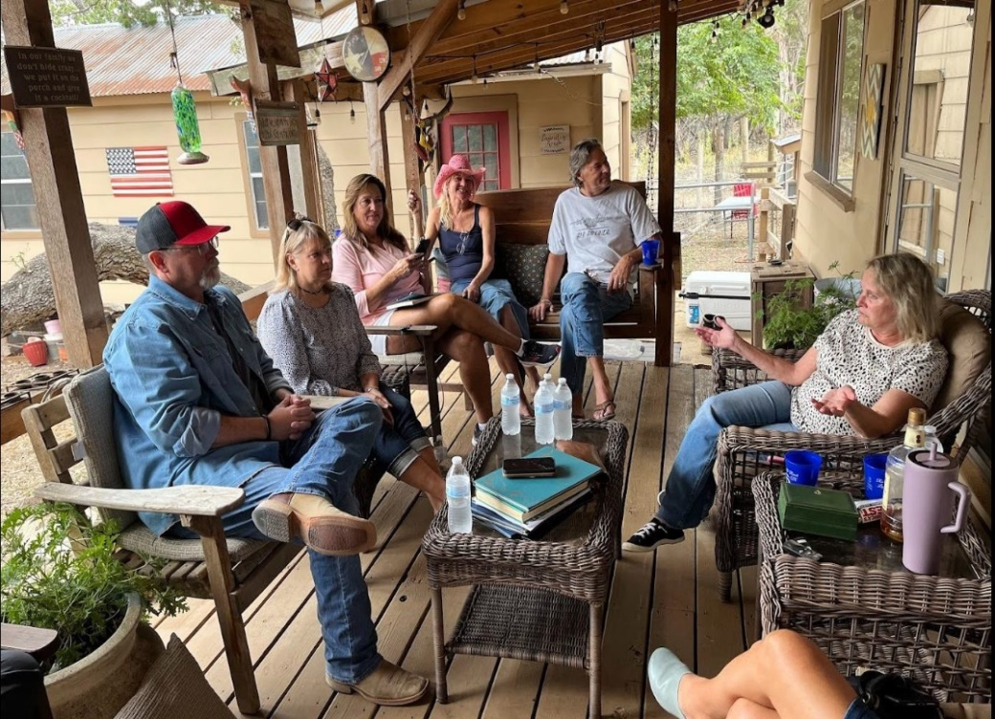
After the interviews with us ended in the afternoon, we relaxed and chatted with Kelly for a while before he drove home to Weatherford, Texas. We enjoyed his insights and his extensive knowledge, and we always welcome him to join us at our Air America functions.
(L to R) - Kelly, Jill, Lesa, Tiffany, Dan, and Vickie

Day 3 - Saturday
Ripper cooked a great breakfast in the morning and sparred with Mike Cash. After breakfast, Terry and Ripper fed the cows and yelled at them some more. Later, we herded everyone together and drove to a Thai restaurant called The Green Mango for lunch. We sat in a large party section where we could all sit at two tables and talk boisterously. After our fantastic Thai lunch, we had a huge surprise when an unknown benefactor paid the lunch bill. Many thanks to our anonymous friend! We all lined up afterwards to commemorate the occasion next to a large ghoulish skeleton on display for Halloween inside the restaurant. Later that evening, dinner was served at the ranch with entertainment provided by our favorite comedy troupe, Ripper and Cash. 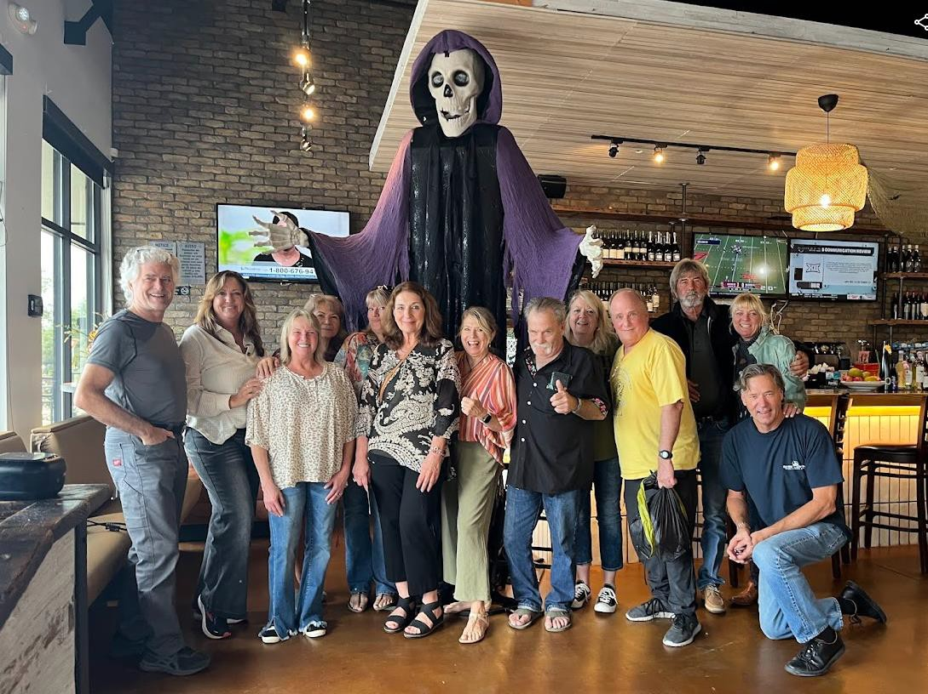

Day 4 - Sunday
Our day of departure finally arrived. Mike Cash left first before sunrise. Mike, aka “Mr. Bulldog,” symbolizes the Air America Bulldog school spirit and we always enjoy his company and comedy. His retelling of his escapades during his years in Thailand are enthralling—although somewhat nerve-racking! Everyone loaded into Tammy’s minivan for the trip to the airport, and we said goodbye until the next time.

Final Thoughts
The New Year’s song, “Auld Lang Syne” always seems to be playing in my head as everyone slowly departs in waves from an Air America Reunion. Each year, there are fewer Air America members who can still attend the reunions and we miss them. The reunions reinforce our strong friendships from our shared journey and we relive the memories and visceral sensations of our lives in Southeast Asia. We look into each other’s faces and we still see the same face—just a bit older. For the kids, the childhood innocence we shared is still there underneath the years. We reminisce for our friends and family who have left us. Our fathers were truly our heroes, and our mothers somehow held everyone and everything together through those chaotic and tumultuous years.

Thailand was my home and the Thai people will always have a special place in my heart. Some of us like me were “adopted” by our Thai maids and they became family. Many of us returned to Thailand years later, some with hopes of finding our lost Thai families. We can only hope their lives were happy and without hardship. I went back to Thailand in 2006 but was unable to find my Thai family: Noi, Vichen, and Nui. We must never forget to make the most of our time on Earth and let our loved ones always know how much we cherish them.

Notes
Kelly Crager’s biography detailing his background and extensive knowledge of American and military history can be viewed at the following link:
https://www.vietnam.ttu.edu/general/bios/cvs/kcrager.pdf

Additional information of AAM is found here: https://libarchives.utdallas.edu/subjects/4

Appendix - Our Fathers
Captain Reuben (Ben) LaVoe Densley: Married to Elizabeth Karen, father to Lesa, Kristine, Tara and Dan. Served with Air American from 1966 to 12/1974. He flew the UH-1 Huey and Twin-Pac.
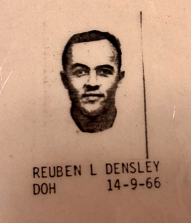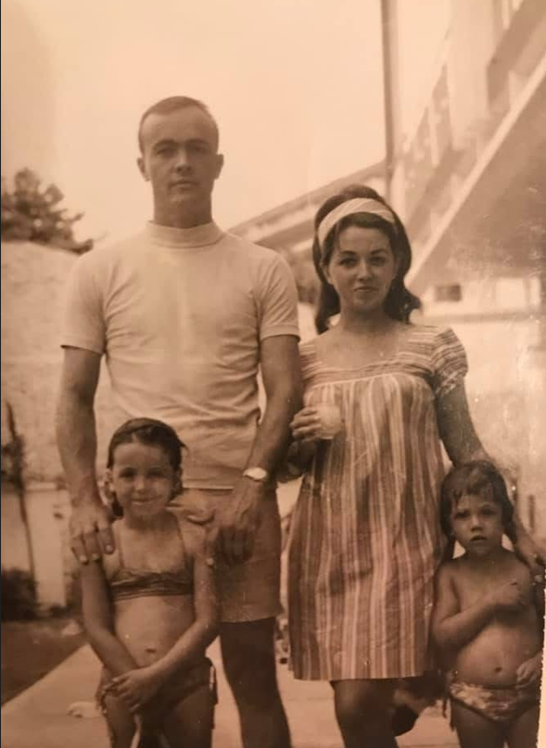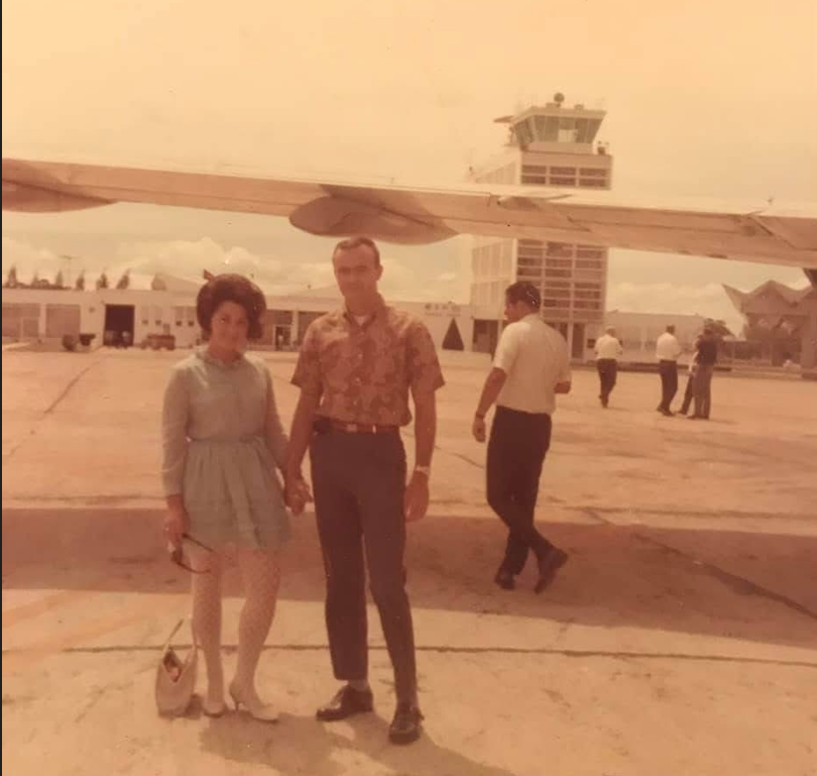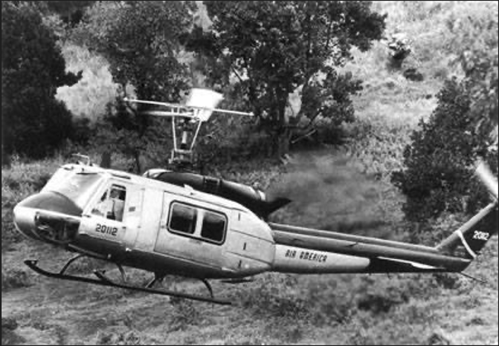

Captain Theodore R Cash: Married to Hazel Kathleen, father to Deborah Jeffer, Penny Ann, Theodore Jr, Patricia Lee and Michael Lee. Served with Air American from 01/1966 to 09/1974. He flew the UH-1 Huey and the 206.

Captain William R Hutchison: Married to Carol Jean, father to Wes and Joel. Served with Air America from 03/1966 to 12/1974. He flew the UH-1 Huey, H-34 and the CH-47 Chinook. William passed away on 3/12/2016.
https://www.muffleyfuneralhome.com/obituaries/William-Richardson-Hutchison?obId=29563360
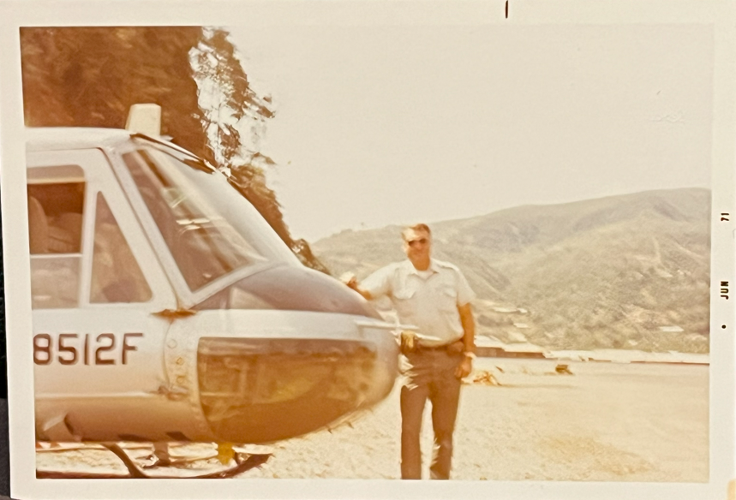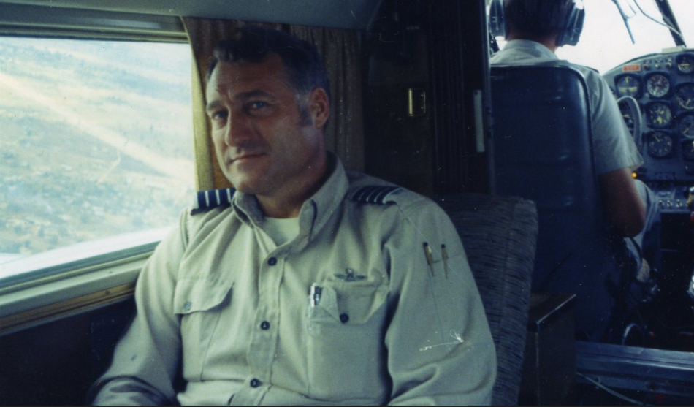
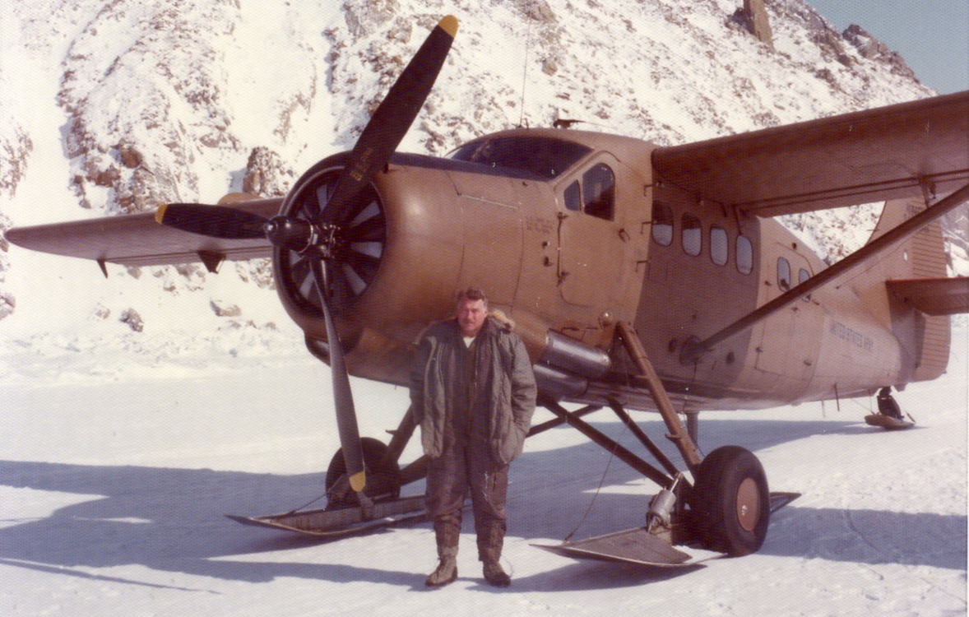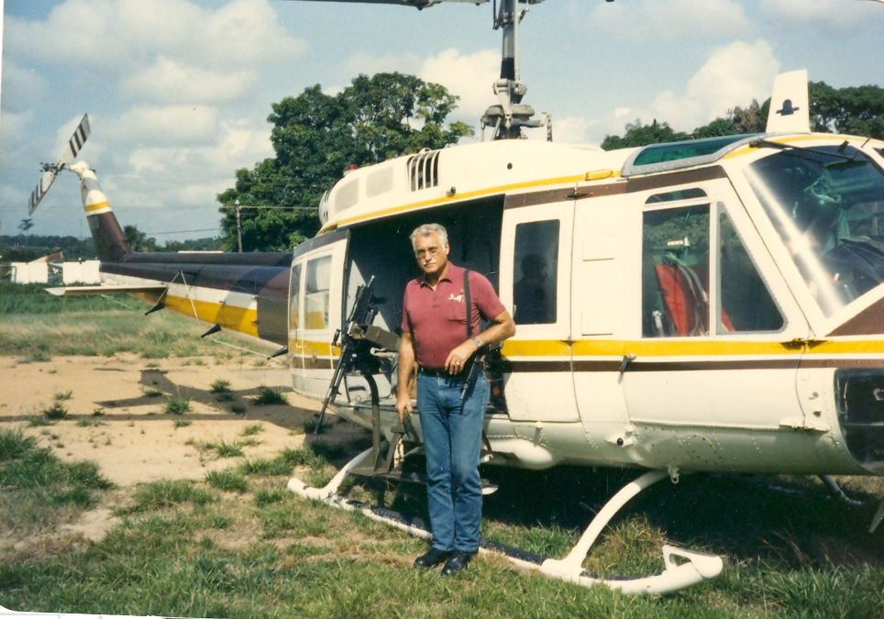

Captain Brian K Johnson: Married to Kelly, father to Blair and Tiffany. Served with Air America from 1966-1974. He flew the UH-1 Huey and SH-58. Brian passed away on 9/26/2022.

Captain Duane Keele: Married to Marlene Bruner, step-father to Tommy, Terry, Timmy, and Teddy. Served with Air America from 1968-1974. He flew the H-34. Duane passed away on January 21, 2025.

Captain David B Kendall: Married to Ruth Evelyn, father to Robert and Vickie.
Served with Air America from 05/1965 to 04/1975. He flew the UH-1 Huey and flew the last flights out of Saigon, evacuating people from the roof of the US
Embassy to the Carriers. David passed away on 05/31/1976.

Captain Robert (Bob) M Murray: Married to Gwen, father to Kim and Mark. Served with Air America 1965-4/15/1975. He flew the Beech 18, C-47, C-46 & the DHC-4 Caribou. Robert passed away on 4/27/2008.
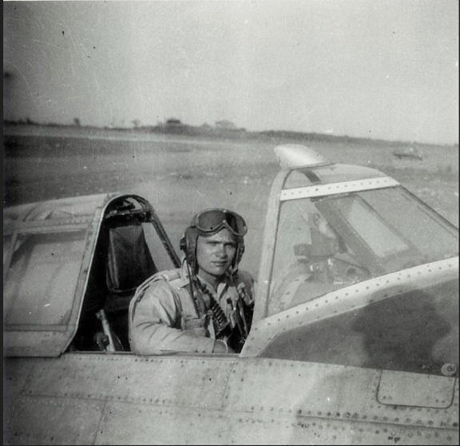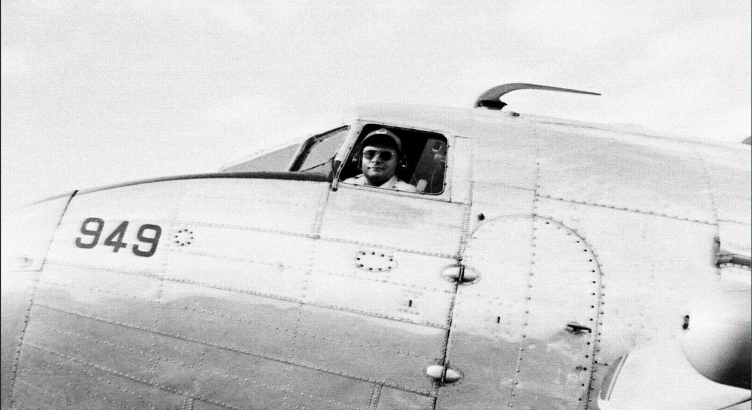
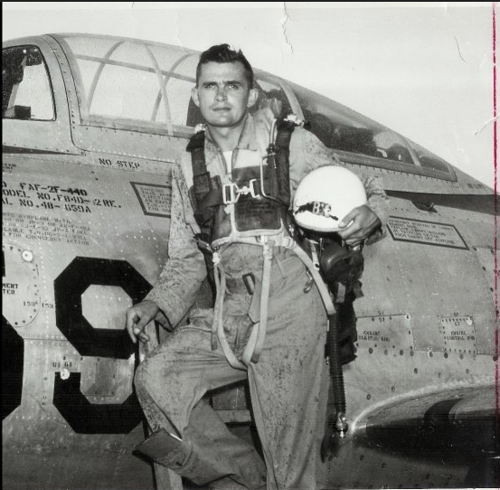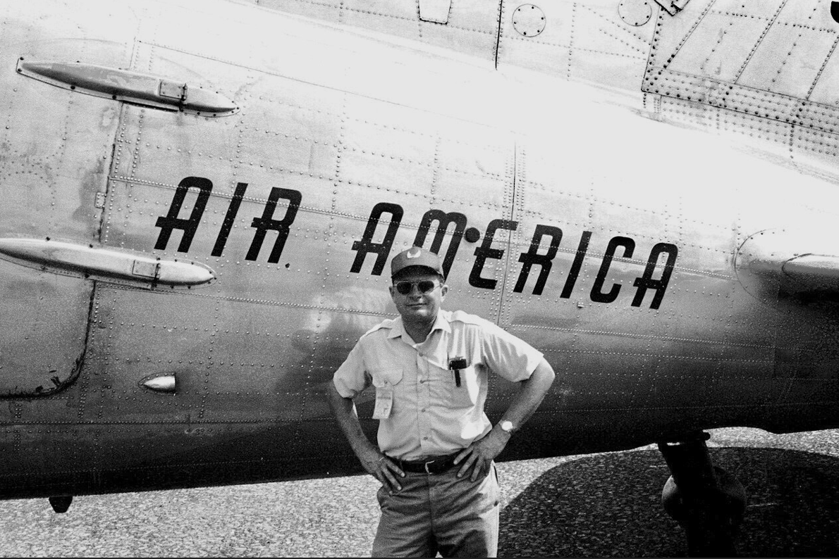

Captain James L (Pete) Parker: Married to Gladys (Happy), father to James, Robert (Randy), Daniel and John. Served with Air America from 4/1962 to 6/1974. He
flew the C-47, DC-3, DC-6, Pilantus Porter, Helio Courier and the C-46. James passed away on 5/1998.

Willie F. "Buddy" Rogers, Jr: Married to Pauline (Polly), father to Terry, Toni, Tammy, Bill (Tiger) and Jeff. Served as the JLD Deputy Commander in Udorn, Thailand from 1972 to 1974 as the CIA Customer and supported the Black Ops missions. After having his first heart attack while closing the CIA AAM Udorn operations in 1974, Buddy passed away later on March 31, 1980 at home in Vienna, Virginia.
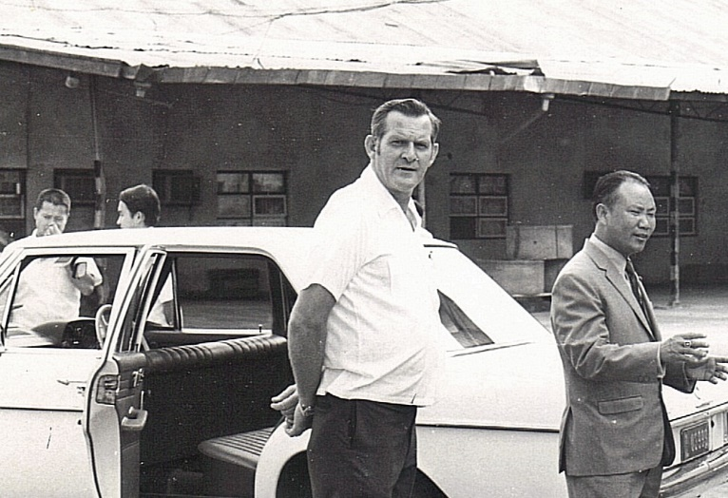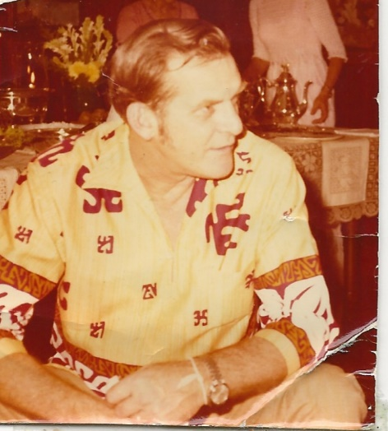

James E Spencer: Married to Vesta, father to David, Suzan and Marlene. Served as the “Customer” from 1972 to 1974.

Captain Richard C Theriault: Married to Ruthan, father to Jill, Christopher, Gabrielle and Alexandra. Served with Air America from 1967-1970 & 1971-1974. He flew the H-34.

